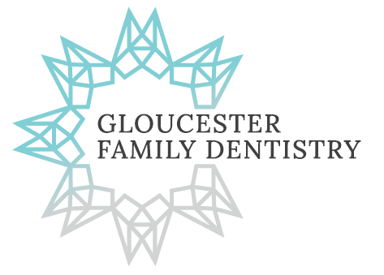
Dental Records Release Form
1900 Innes Rd, Unit #B5C, Ottawa, ON K1B 3K5 Tel: (613) 749-7370 Fax: (613)749-9772
info@gloucesterfamilydentistry.com

Patients Name: .
Date of Birth: .
Best Contact Number: .
Other Family Members to Transfer: .

Previous Dentist or Practice Name: .
Email: .
Phone Number: .
Fax Number: .
** PLEASE FORWARD ANY OF THE FOLLOWING INFORMATION THAT YOUR OFFICE HAS REGARDING THE ABOVE LISTED PATIENT(S) **
Bitewings – Date taken: .
PAs – Date Taken: .
PAN – Date Taken: .
Complete Oral Exam: .
Last Recall Exam: .
Last Polish Fluoride: .
** PLEASE SEND MOST RECENT COPY OF PERIO CHART FOR ABOVE PATIENT(S). THANK YOU.**

I hereby give you permission to release any and all of my dental records to Gloucester Family Dentistry.
Patient’s Signature: . Date: .

